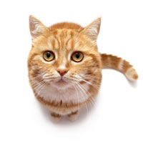
Deb, My Cat
By Hallie Christensen
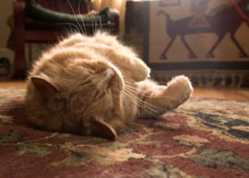
I have a cat and she has lots fluff just as a duck. I call her Deb.

Deb naps in the sun, but if she is up she will just snack or bat and scratch.

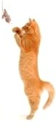
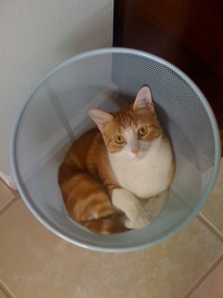
Deb will bat her rat and she will bat her chick and she will bat at me. She bats at the trash, too. Mom yells, “Deb, do not mess in that trash!”

If Deb does not nap or bat and scratch, she will ask to be fed. I put her snack in a big cup that is red. The snack she is fond of best are wet tan bits that smell of fish… Yuck, Deb!

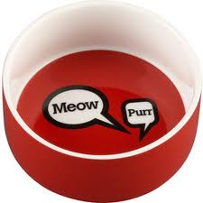
Deb must drink, too, but she will just drink if it is fresh from the tap. Dad says she is a snob.

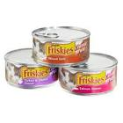
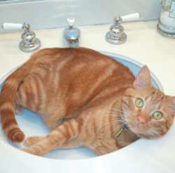
We then let Deb out for a spell. She will duck back by the shrubs so none can catch sight of her fluff. Deb can glimpse at the kids, but the kids do not catch a glimpse of Deb. Deb will not glimpse at the dogs at all. Dogs just pant and lick and rant.

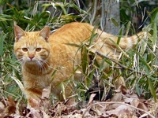
When the sun sets my mom and my dad and my clock all call and tell me to climb up to my bed. I crack the front and yell, “The sun is set, Deb! Get to bed!” Deb will come back, but she slinks so I do not catch sight of her fluff. Then, zip! Quick as a flash, in Deb will dash!

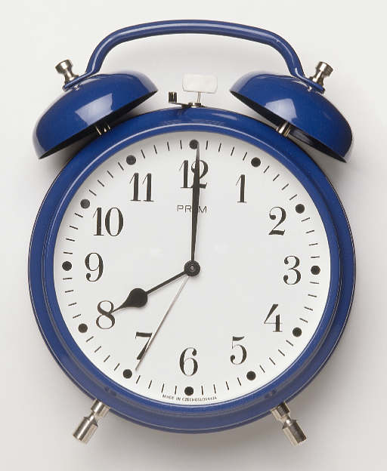
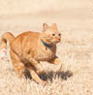
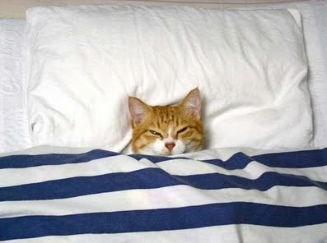
Deb and I will nap in my bed. Since Deb must rest, she is glad. Deb nods off and that is that.

