Slim Bill Gets a Hat
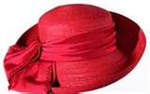

by Dani Rosener

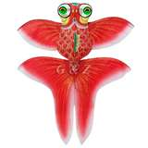
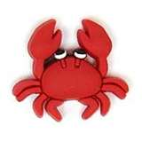
Slim Bill is a red crab. Prim Liz is a
red fish. Bill and Liz swim and splash
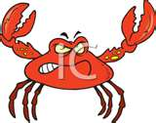
in the hot sun. On a hot day, Slim Bill
got mad, " I am grim in this hot sun!"
I can't stand this hot, hot sun!" Prim Liz felt sad for her hot, red crab. On a whim, she did grab her hat with
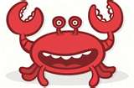
her fin. "You can swim with my hat!" Prim Liz had a big, red hat with a big, red brim for Slim Bill to put on. "It fits! You can swim in a hat and have fun in this hot sun!" With a nod, Slim Bill put on her hat. He was glad for his big, red hat with a big, red brim. With a grin and a hug, Slim Bill was full of zip. "You are a slick fish, Prim Liz!" The sun was hot, but Slim
Bill and Prim Liz still had fish fun. If the sun is hot, they just swim and splash and don big, red hats. *images courtesy of www.googleimages.com

