Can He Swim?

By: Victoria Barron

a decodable book reviewing short vowels

Dedicated to Nicky, who loves to read!

This is Nick. His dog is MJ. They had fun!
MJ wags and wags.

11
2

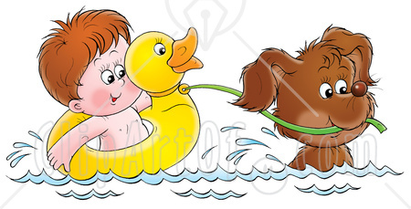

They splish and splash. It is hot and Nick will swim.
They swim in the hot sun.

3
10

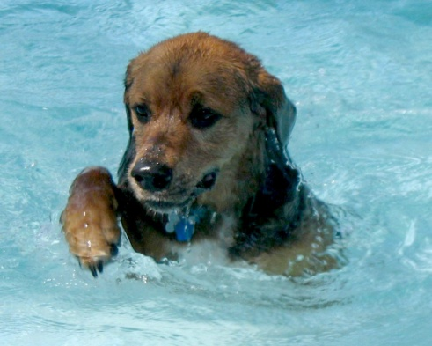

Can MJ swim? MJ can swim!
He is a fun pet.

9
4

Nick tells MJ to get in. Nick yells at him!
The dog will not get in! The dog will not get in.
7
6

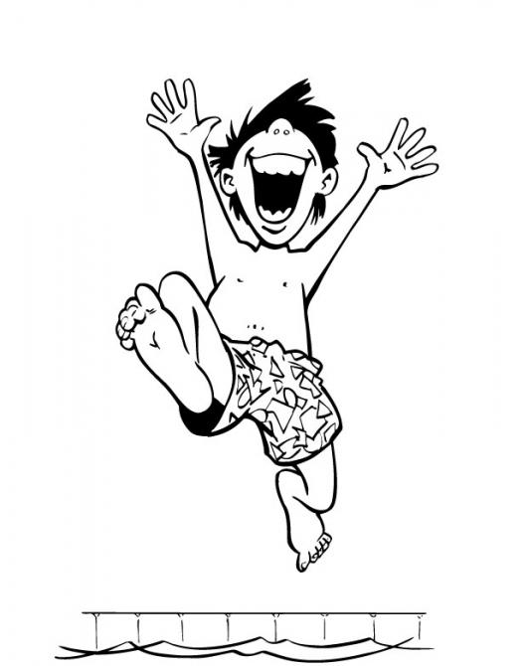
What will Nick do? Nick flips in!
Nick will jump in with him!

5
8

