Sam, the Class Pet
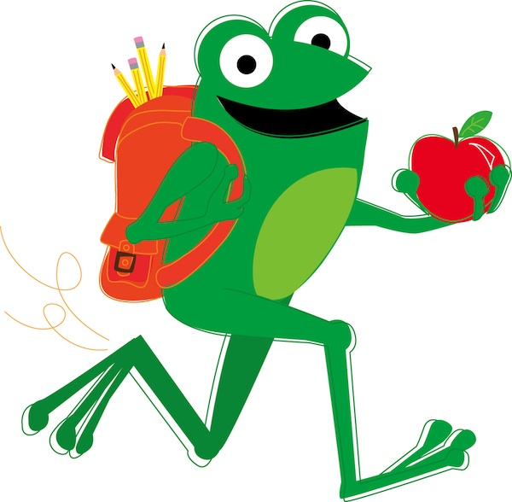

By: Reagan Gilbert

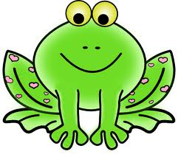
My class has a pet frog.
He is Sam.

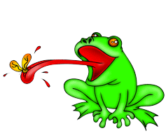
We fed Sam.
Sam had a bug for lunch. Yuck!

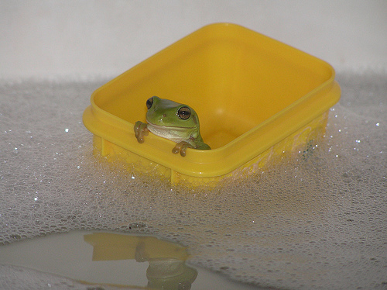
Sam has a bath. Splish Splash!
Sam jumps from the sink.

We lost Sam!
We had a hunt for him.

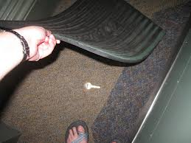

We checked the mat.
Sam was not there!

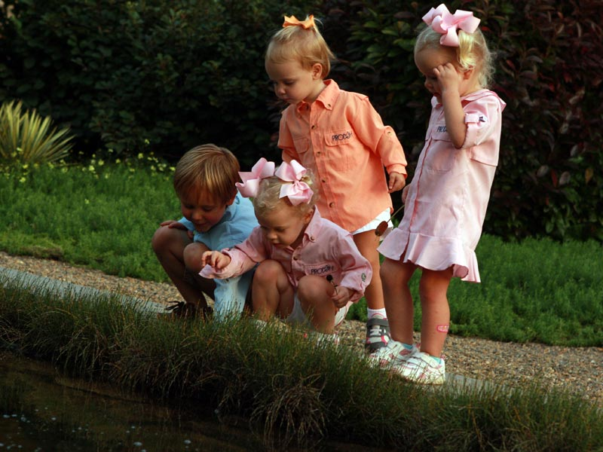
We checked the grass.
Sam was not there!

We had no luck!
We were sad.

There was a big thump!
We saw Sam jump from a desk!
We gasped!

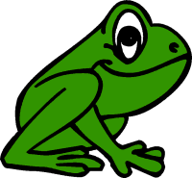

Sam was back!
We were glad!
The class yelped and yelped!

